|  |  |
| --- | --- |
| **Name** | **Shuvo Biswas** |
| **ID** | **IT-16014** |
| **Course Title** | **Operating System Lab** |
| **Course Code** | **ICT-3108** |
| **Lab No** | **05** |
| **Lab Report Name** | **Connecting a database (MySQL) with Linux** |
| **Submission Date** | **16-10-2019** |

**Objectives:**

From this lab we learnt about how to

i) Install MySQL on Ubuntu

ii) Log into MySQL by Linux.

iii) Create database table.

iv) Insert data into table.

v) Describe table.

vi) Alter table.

vii) Modify table.

viii) Drop data from table.

ix) Update data of table.

x) Where and delete operation.

**1.Install MySQL on Ubuntu .**

**We Install the MySQL server by using the Ubuntu package manager.**

First, we have to **update the package index** and then you have to install the MySQL server.

At first we open our linux operating system.Then we go to terminal and write below command

**sudo apt-get update**

then we reset our operating system and again we write below command in our Ubuntu terminal.

**sudo apt-get install mysql-server**

After few minutes we successfully install mysql in our linux.

**2. Log into mysql by linux ubuntu.**

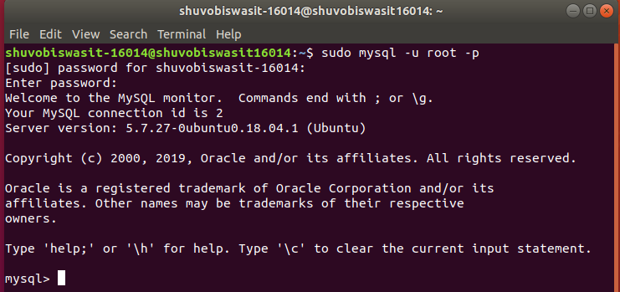

**3. create database Table:**

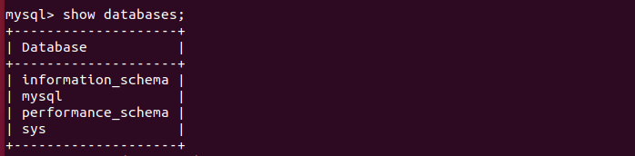

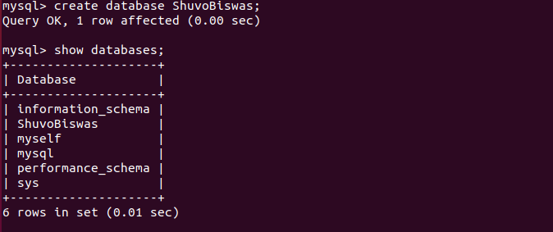

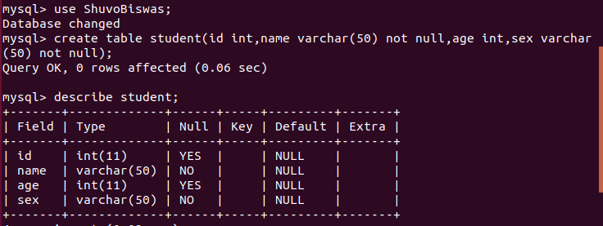

**4. insert data into table :**

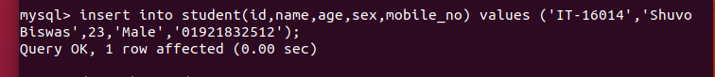

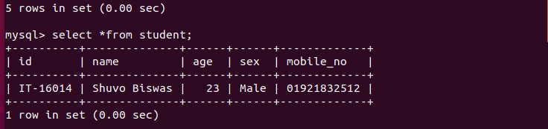

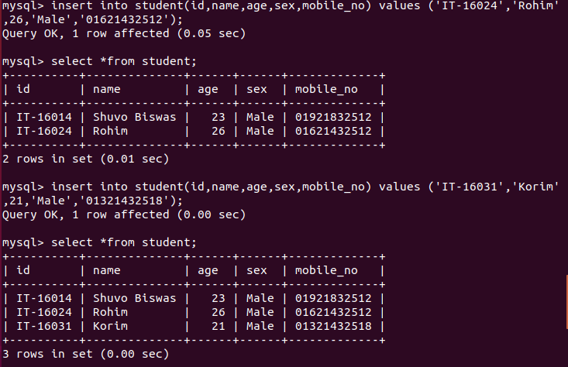

**5. Describe table:**

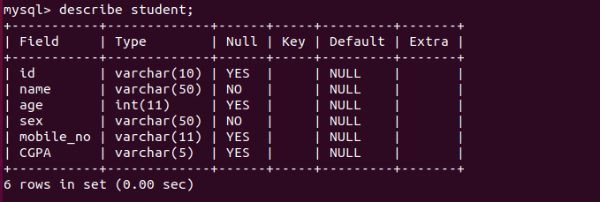

**6. alter table :**

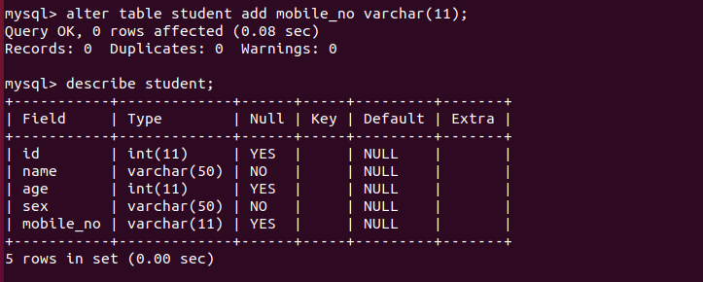

**7.modify table:**

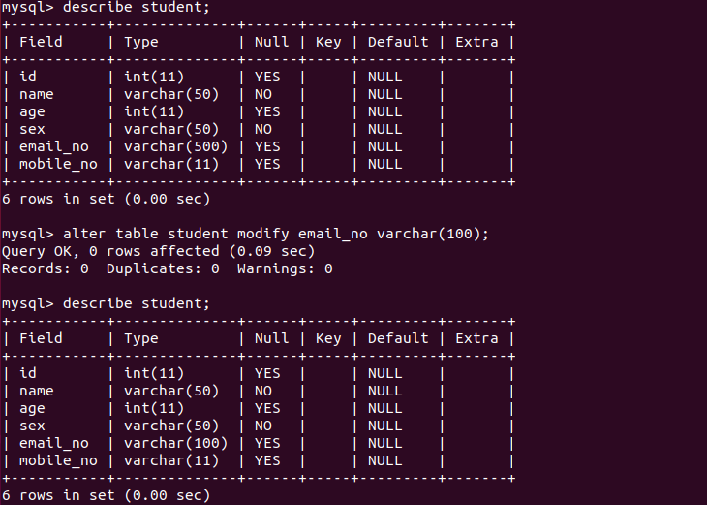

**8. drop data from table:**

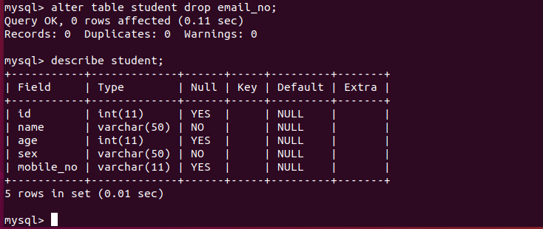

**9.update data of table:**

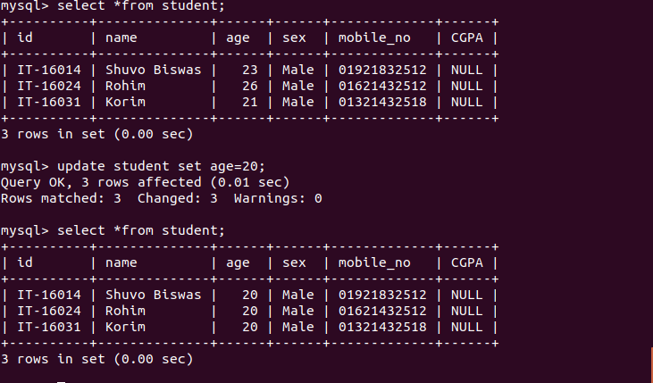

**10. Where and delete operation:**

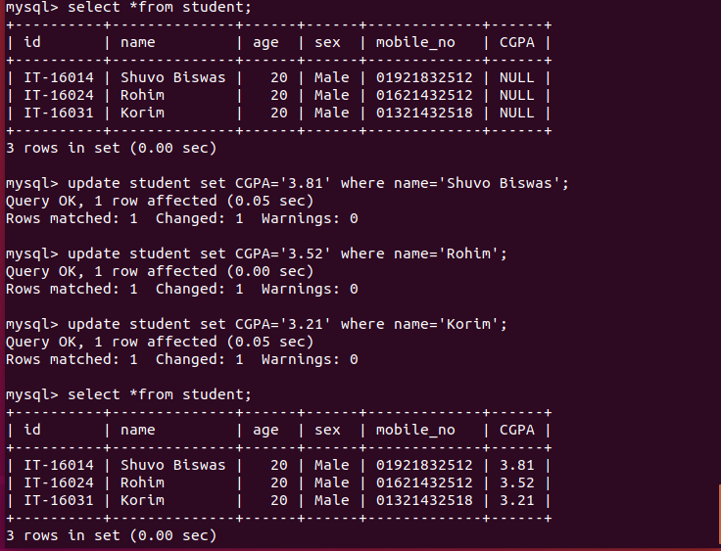

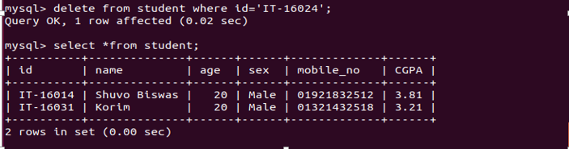

**Description:**

MYSQL is the **open source relational database management system** used to store and retrieve data for a popular applications. It uses the **structured query language** to handle the database. In the present world, over 60% of the websites and applications on the internet use MySQL. Using MySQL we can **create and manage the large database.** World's many large sites are running using the MySQL. We have learned **how to secure the newly installed MySQL.** By using MYSQL we create database table, insert data into table, describe table, alter table, modify table, drop data from table, update data of table.